**LINKS:**

**GITHUB:**  <https://github.com/pranavko12/Unity-Games>

**Essentials of real-time 3D:** <https://play.unity.com/en/games/522bd2bf-2a93-49b1-9009-de8ea8d5316b/real-time-3d>

**Essentials of programming:** <https://play.unity.com/en/games/f9723c19-77d0-44f7-a3cb-6fb6327b9930/programming>

**Essentials of real-time 2D:** <https://play.unity.com/en/games/b7cb50f7-f3aa-47f2-a329-b9afde367b16/real-time-2d>

**Car Prototype:** <https://play.unity.com/en/games/78ef0272-4f19-4d52-8a2a-105f704218f1/car-prototype>

**Plane Prototype:** <https://play.unity.com/en/games/18eab407-0baa-4e5a-abca-bca72f93bc44/plane-prototype>

**UNITY ESSENTIALS:**

**Get started with Unity:**

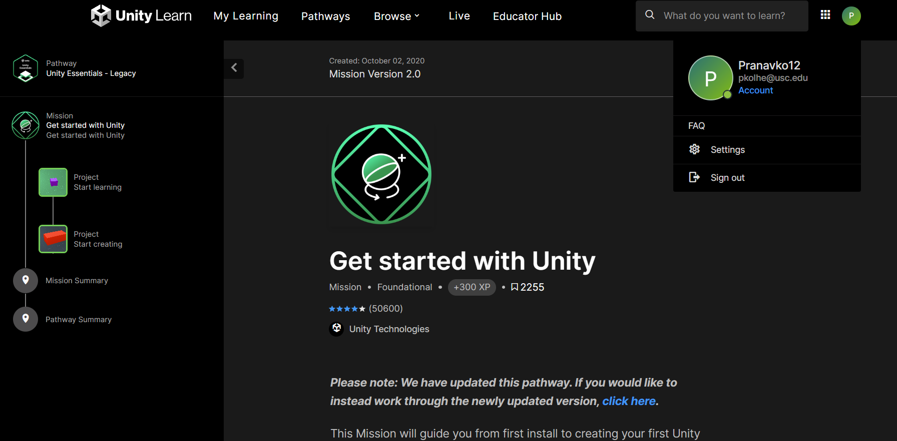

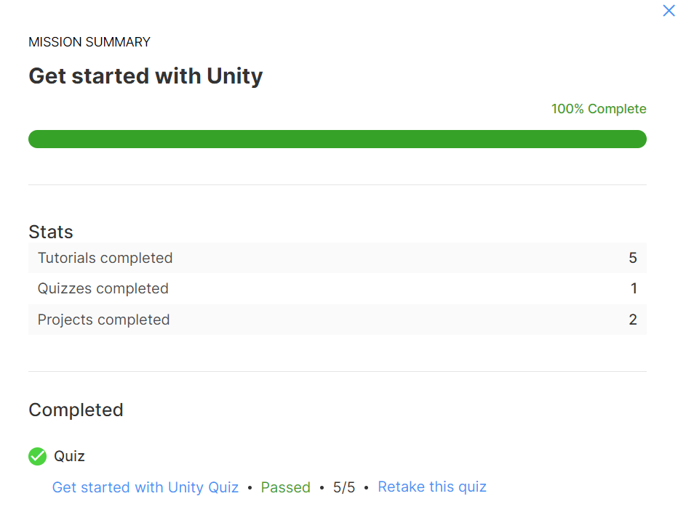

**EXPLORE UNITY:**

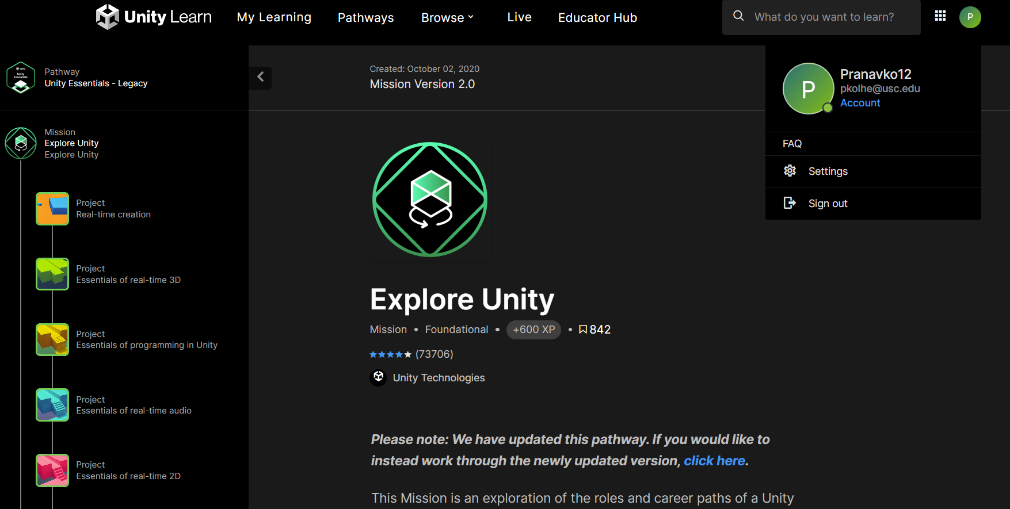

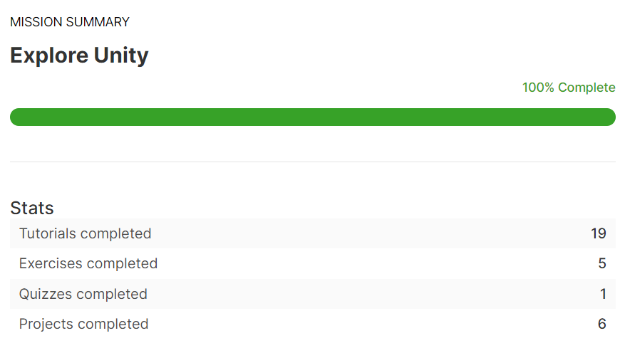

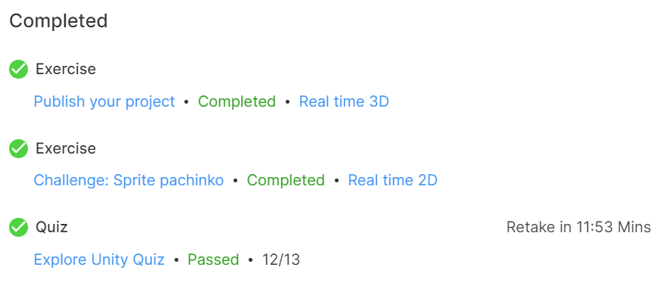

**LEARN UNITY:**

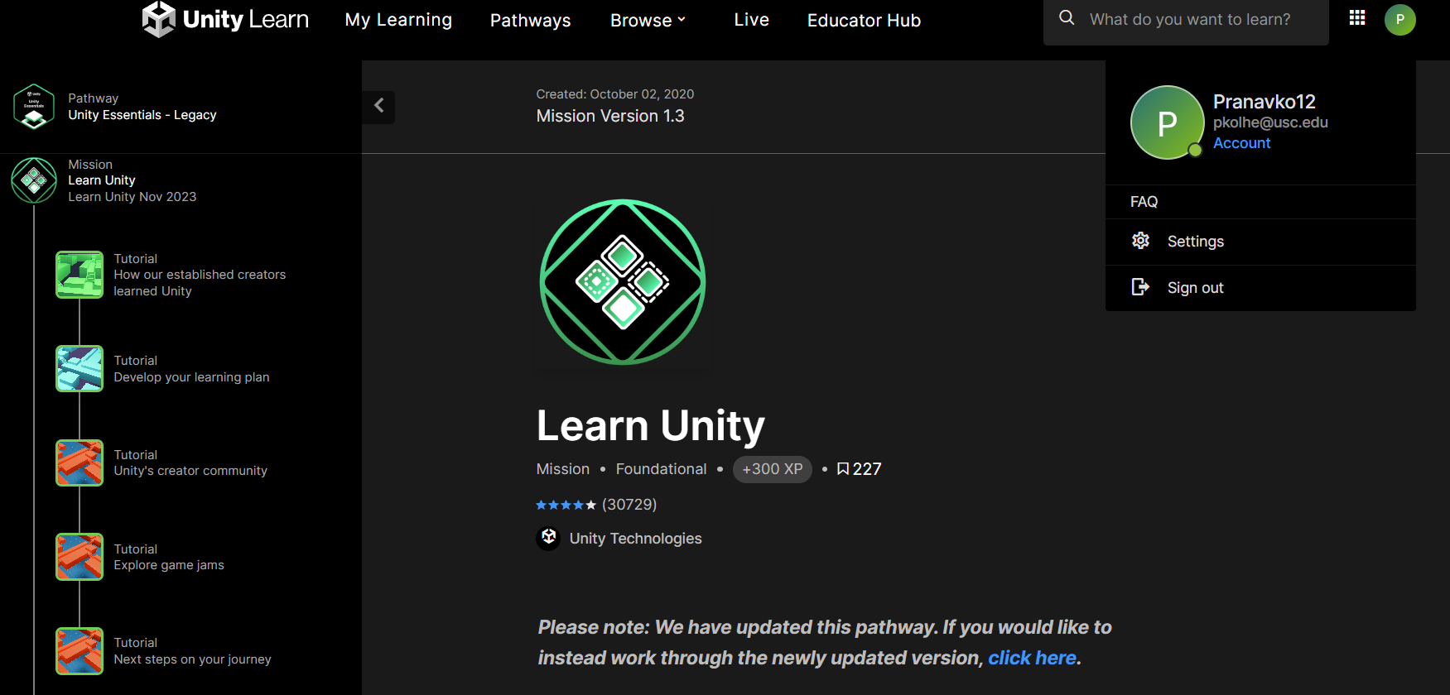

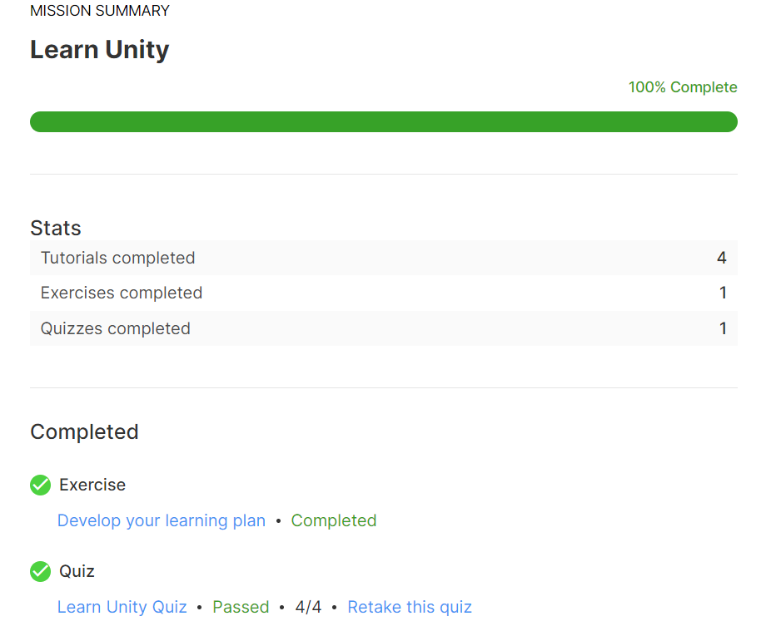

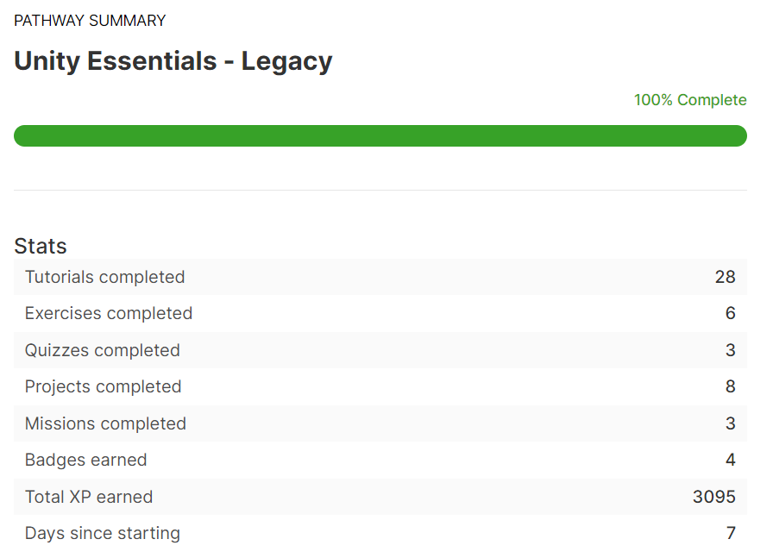

**JUNIOR PROGRAMMER**

